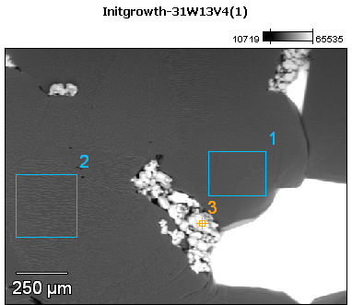

Image Name: Initgrowth-31W13V4(1)

Image Resolution: 512 by 384

Image Pixel Size: 3.30 µm

Acc. Voltage: 13.0 kV

Magnification: 75

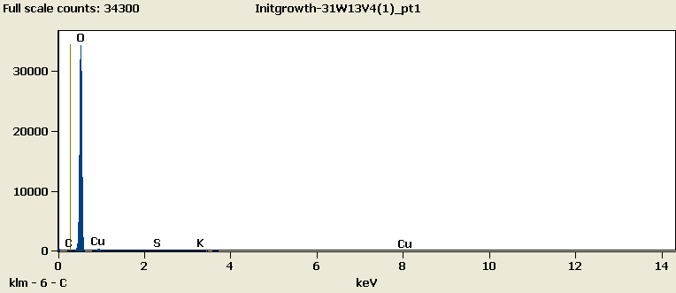

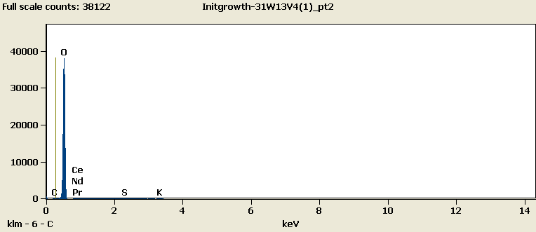

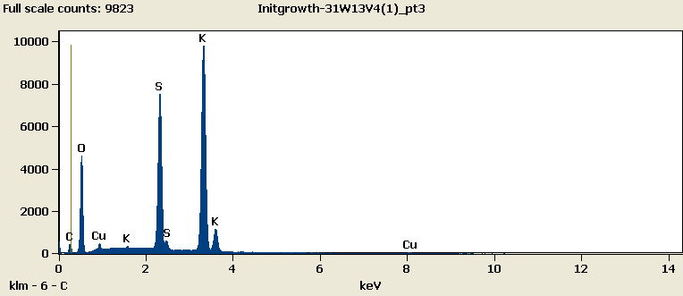

Weight %

|  |  |  |  |  |  |  |  |  |
| --- | --- | --- | --- | --- | --- | --- | --- | --- |
|  | ***C-K*** | ***O-K*** | ***S-K*** | ***K-K*** | ***Cu-L*** | ***Ce-L*** | ***Pr-L*** | ***Nd-L*** |
| ***Initgrowth-31W13V4(1)_pt1*** | 0.00 | 91.58 | 0.22 | 0.38 | 7.82 |  |  |  |
| ***Initgrowth-31W13V4(1)_pt2*** | 0.00 | 99.35 | 0.23 | 0.42 |  | 0.00 | 0.00 | 0.00 |
| ***Initgrowth-31W13V4(1)_pt3*** | 4.01 | 29.59 | 20.35 | 44.08 | 1.98 |  |  |  |

Weight % Error (+/- 1 Sigma)

|  |  |  |  |  |  |  |  |  |
| --- | --- | --- | --- | --- | --- | --- | --- | --- |
|  | ***C-K*** | ***O-K*** | ***S-K*** | ***K-K*** | ***Cu-L*** | ***Ce-L*** | ***Pr-L*** | ***Nd-L*** |
| ***Initgrowth-31W13V4(1)_pt1*** | ±0.00 | ±0.29 | ±0.04 | ±0.04 | ±0.19 |  |  |  |
| ***Initgrowth-31W13V4(1)_pt2*** | ±0.00 | ±0.31 | ±0.04 | ±0.04 |  | ±0.00 | ±0.00 | ±0.00 |
| ***Initgrowth-31W13V4(1)_pt3*** | ±0.16 | ±0.21 | ±0.11 | ±0.22 | ±0.11 |  |  |  |

# Cations

|  |  |  |  |  |  |  |  |  |
| --- | --- | --- | --- | --- | --- | --- | --- | --- |
|  | ***C-K*** | ***O-K*** | ***S-K*** | ***K-K*** | ***Cu-L*** | ***Ce-L*** | ***Pr-L*** | ***Nd-L*** |
| ***Initgrowth-31W13V4(1)_pt1*** | 0.00 | 0.00 | 0.00 | 0.00 | 0.00 |  |  |  |
| ***Initgrowth-31W13V4(1)_pt2*** | 0.00 | 0.00 | 0.00 | 0.00 |  | 0.00 | 0.00 | 0.00 |
| ***Initgrowth-31W13V4(1)_pt3*** | 0.00 | 0.00 | 0.00 | 0.00 | 0.00 |  |  |  |